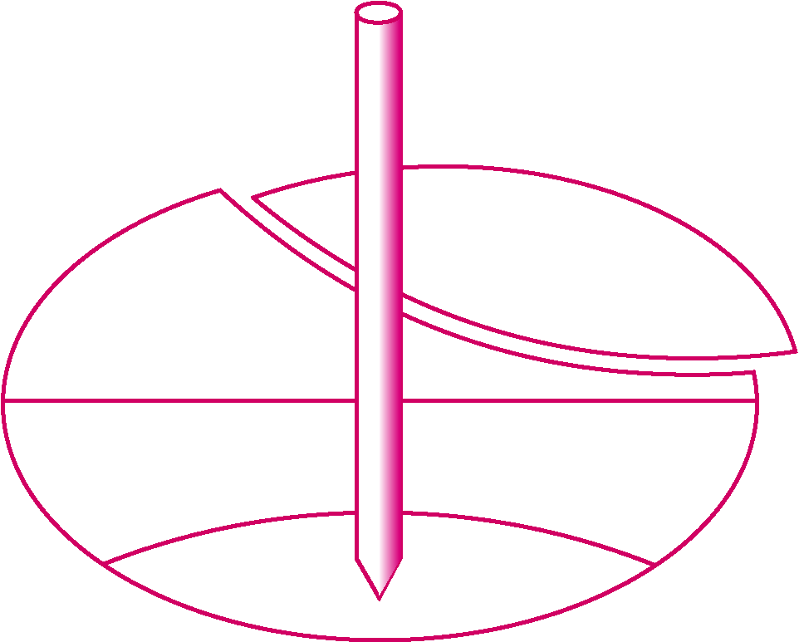
ISSMGE Technical Committee 16
Ground Property Characterization by In-Situ Tests
http://www.webforum.com/tc16

International Society for Soil Mechanics & Geotechnical Engineering
http://www.issmge.org

TC 16 Meeting Agenda at ICSMGE - Alexandria - Tuesday, 6 Oct. 2009

1. Welcome

2. Introduction of TC 16 Core Members, Members, Advisors, and Friends of TC16

3. Discussion of new officers

4. Website changes - Special thanks to Dr. Rainer Massarsch

5. Past events listed in our ISSMGE Report (2005-2009)
2005 (Sept) - 16th ICSMGE - Osaka
2006 (April) - 2nd Intl. Conference on Flat Dilatometer (DMT) - Arlington, VA

2006 (June) - GeoShanghai International Conference, China

2006 (Dec.) - 2nd Singapore Characterization Workshop

2007 (Sept) - 14th ECSMGE, Madrid

2008 (April ) - 3rd Intl. Conf. Site Characterization (ISC-3) - Taipei

2008 (Aug) - 11th Baltic Sea Geotechnical Conference, Gdansk

2009 (Mar) - International Foundation Conference, Orlando

6. Upcoming Events:
6a. Second International Symposium on Cone Penetration Testing (CPT'10)
Hyatt Regency Resort, Huntington Beach, CA
Hosts: Peter K. Robertson and Kelly Cabal, Gregg In-Situ, California.
May 9-11, 2010: Website: www.cpt10.com
178 abstracts accepted and papers now being received for review
Regional Reports prepared for the proceedings
2010 James K. Mitchell lecture to be given by Tom Lunne
6b. Fourth International Conference on Site Characterization (ISC-4)
Sept. 2012: Recife, Brasil (following the annual conference by the
Brasilian Society SMGE)
Host: Professor Roberto Quental Coutinho, Federal Univ. Pernambuco

7. Additional activities and discussion
7.1. Standards (ASTM, CEN, ISO)
7.2 Publications
7.3 Other

TC 16 Core Committee:

Paul W. Mayne (chair), Georgia Institute of Technology, USA An-Bin Huang, National Chiao-Tung University
Martin Fahey, University of Western Australia Tom Lunne, Norwegian Geotechnical Institute
Fernando Schnaid, Univ. Fed. do Rio Grande do Sul, Brasil Zbigniew Mlynarek, Poznan University, Poland
John J.M. Powell, Building Res. Establishment, UK (sect.) Emoke Imre, Technical Univ. of Budapest, Hungary

TC 16 Advisors
Mike Jamiolkowski, Politecnico di Torino, Italy Peter Robertson, Gregg In-Situ, California, USA
Rainer Massarsch, GeoEngineering AB, Sweden Roberto Coutinho, Fed. Univ. Pernambuco, Brasil

