Autoseis Hammer Shear Wave Generator

Model H-GRT-HT-001

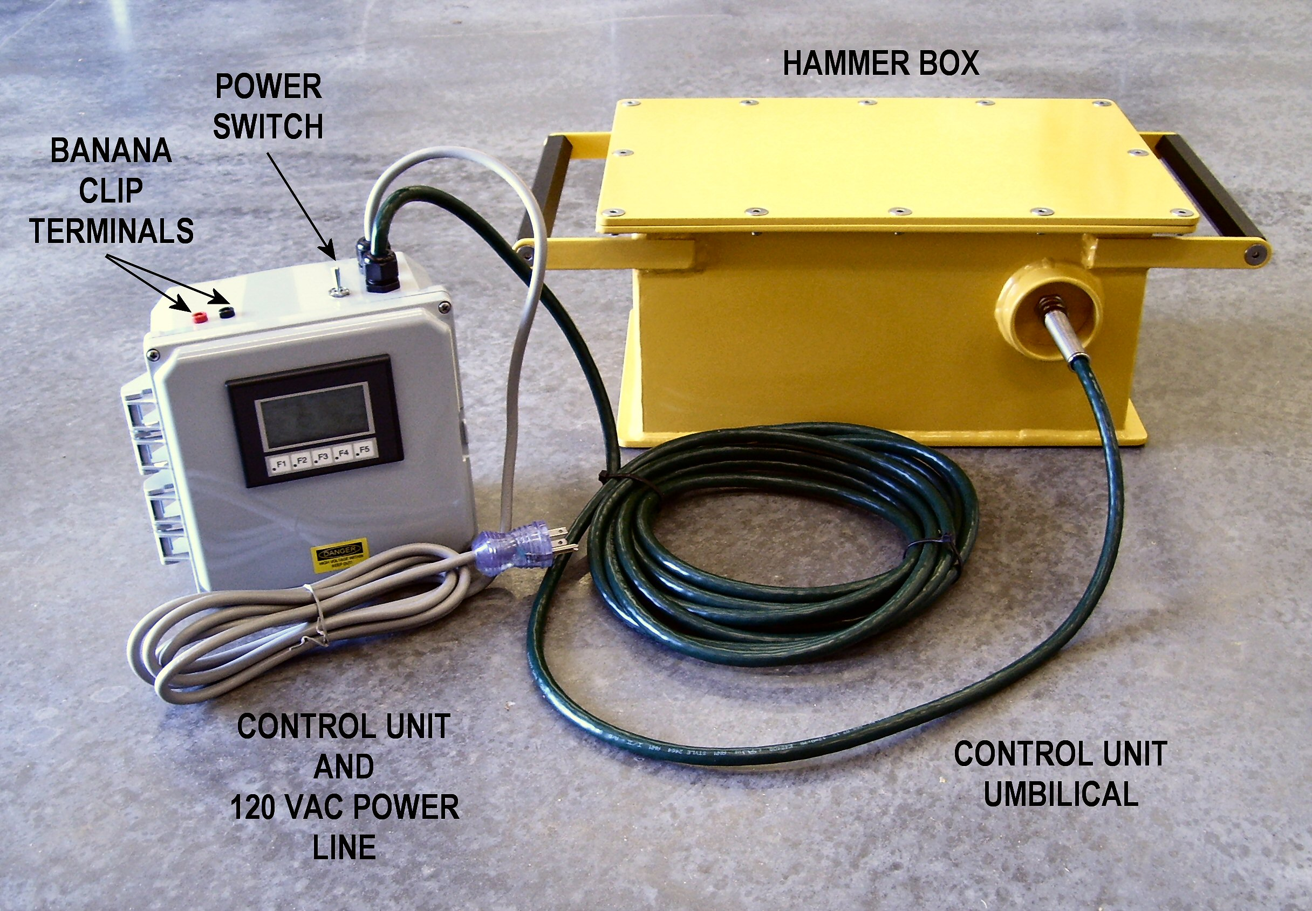

- For use in down-hole shear wave velocity measurement systems
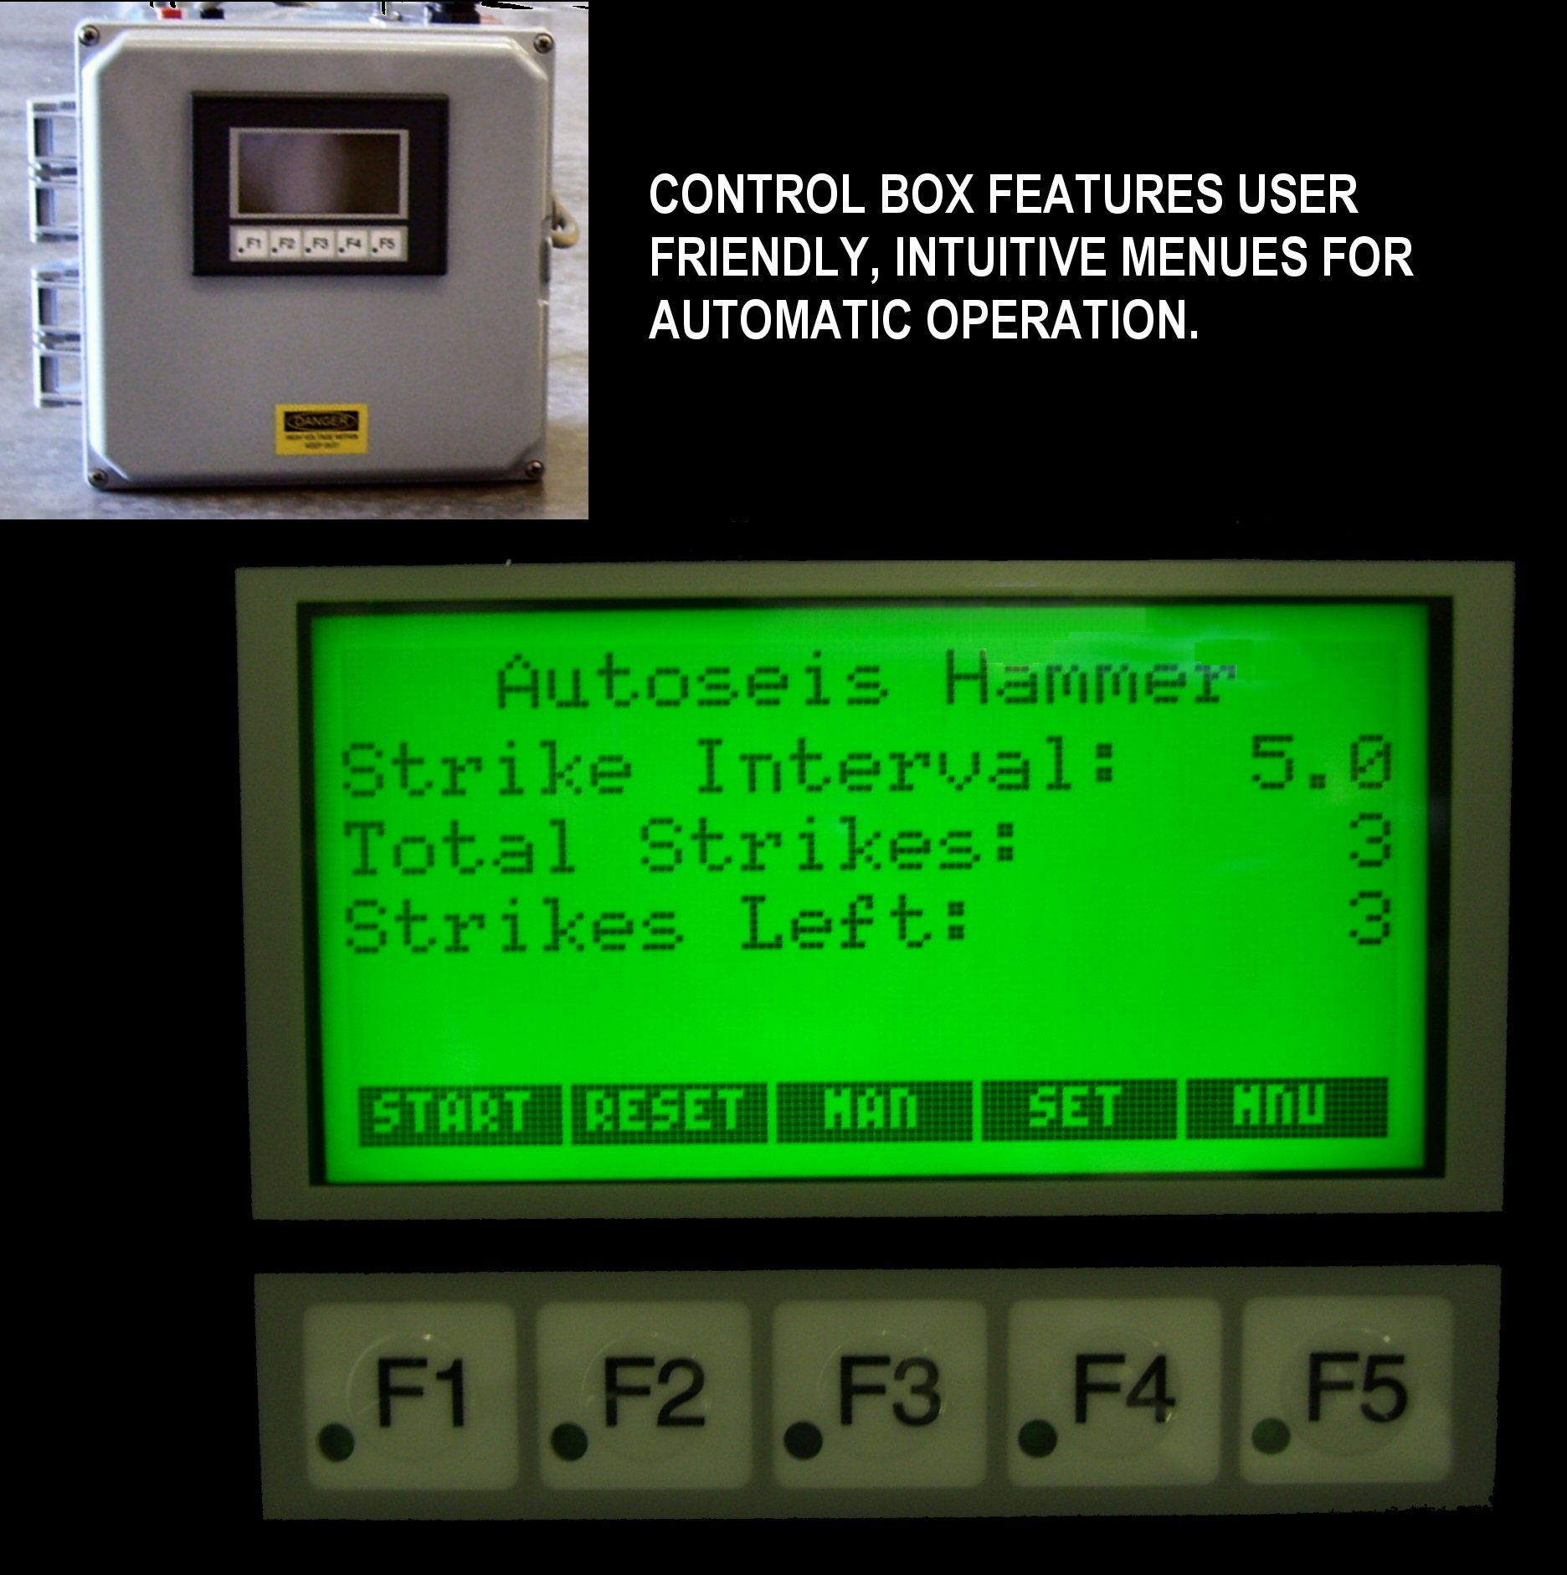
Manufactured under license from Georgia Tech Research Corporation, USA

- Controlled, reproducible generation of horizontally polarized vertically propagating shear waves

- Energy of impact is transmitted to the ground parallel to the ground surface

- Less horizontal shear stress in the ground

- Manual or Automatic Operation

- Rugged, field tested design

For Sales and Customer Service:

Finite Designs, Inc.
125 Wes Walker Memorial Drive
Ball Ground, GA 30107 USA
Tel: (678) 880-3935
Fax: (678) 880-3936
Email: sales@finiteprecision.com

Autoseis Hammer Shear Wave Generator

Model H-GRT-HT-001

The Autoseis Hammer Shear Wave Generator is a remotely operated device for generating horizontally polarized vertically propagating shear waves for use in down-hole shear wave velocity measurement systems. The seismic signals are generated by an offset mass rotating in a plane perpendicular to the ground surface, which impacts an object coupled to the ground surface at the moment the motion of the mass is tangent to the ground surface. The energy of impact is transmitted to the ground parallel to the ground surface. Autoseis Hammer Shear Wave Generator uses a rotating motion instead of a horizontal motion. Because the acceleration is not horizontal, the reaction forces caused by acceleration of the mass create less horizontal shear stress in the ground prior to the desired time (impact).

The shear wave is generated by a steel hammer striking a steel anvil. The hammer is accelerated in a rotating manner causing it to strike an anvil with sufficient force to generate a repeatable shear wave that can be detected by a geophone implanted in the ground.

The most unique part of the Autoseis Hammer Shear Wave Generator is the rotation of the hammer through 90 degrees to a position parallel with the ground surface where it is released. In this position, all reactions from the release of the hammer are in the vertical direction. This is important because it permits the release and generation of a shear wave without the reaction impulse of linear actuated devices.

For questions or comments concerning application and theory, contact:
Paul W. Mayne, PhD, P.E.
Professor - Geosystems Engineering Group
School of Civil & Environmental Engineering
Georgia Institute of Technology
790 Atlantic Drive, Mason Bldg 241
Atlanta, GA 30332-0355
Tel: 404-894-6226
Fax: 404-894-2281
Email: paul.mayne@ce.gatech.edu

For Sales, Customer Service, Delivery or Warranty inquiries, contact:
Finite Designs, Inc.
125 Wes Walker Memorial Drive
Ball Ground, GA 30107 USA
Tel: (678) 880-3935
Fax: (678) 880-3936
Email: sales@finiteprecision.com

For information concerning the piezoelectric trigger, contact:
GISCO Geophysical Instrument & Supply Co.
6323 Cambridge Street
Minneapolis, MN 55416 USA
Tel: (800) 523-1526
Fax: (952) 926-5498
Email: sales@giscogeo.com

Specifications:
Hammer and Control Box, Electrical
110/120 VAC
50/60 Hz

Control Box
Positive terminal (red) 12-VDC banana clip port
Negative terminal (black) 12-VDC banana clip port

Hammer Box, Piezoelectric Trigger
Type: Gisco G-ST-04-02-001-02
Output: Contact closure (open collector NPN)
Pulse Width: 5-ms
Max Voltage: 20-volts
Max Amperage: 100-ma
Protection: Over current, over voltage and reverse polarity
Size: 1-inch diameter x 3.5-inch length
(25mm diameter x 88mm length)

H-GTR-HT-001-MSF-0 2007-05-10

